Announcing 2018 Fair Book
Cover Competition

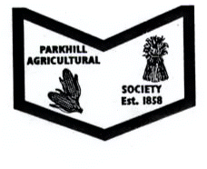
PARKHILL AGRICULTURAL SOCIETY
P.O. BOX 87
PARKHILL, ON N0M 2K0

www.parkhillfallfair.com

The Parkhill Fair Board is again holding a cover competition.

It is open to all elementary school aged children.

2 categories – Jr. Grades 1 - 4
Sr. Grades 5 - 8

Prizes for each category:
1st is $ 50.00, 2nd is $ 30.00 and 3rd is $ 20.00

Cover size – Minimum – 8.5” x 11” (23cm x 28cm)
Maximum – 11” x17” (28cm x 44cm)

We are looking for something that is eye catching which may be used for advertising purposes and the fair book cover.

The owner’s name, grade and school must be clearly labeled on the back of each entry.

Your poster must include the following information:
Celebrating: 160th. Parkhill Fair
Dates: Sept. 14th to 16th, 2018
2018 Theme: Pioneer days to Modern ways…”160 years later.”

All entries will be picked up at your school at noon on Friday, March 2nd., 2018.
All entries will be returned along with the entry prize money No later then April 1st.2018.

Judging Criteria:
Overall appearance
Attraction and holds attention
Required information clear
Quality of materials / end product

